RIFT VALLEY NATIONAL POLYTECHNIC

PROPOSAL FOR THE ADOPTION OF RVNP CAMPUS HUB / RVNP SOCIAL APP

A Unified Digital Platform for Marketing, Information Sharing, and Community Engagement

Prepared by: Davis Okoth
Company: HDM
Date: September 2026

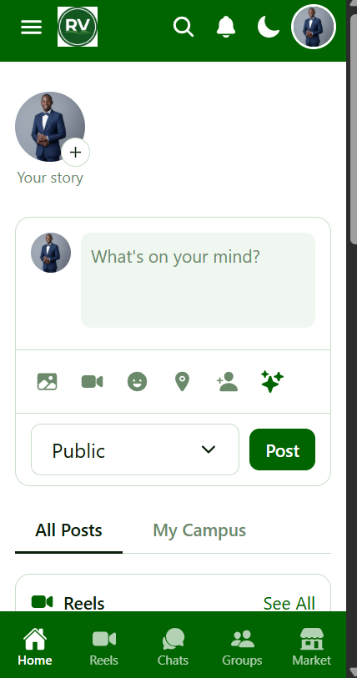

1. Executive Summary

RVNP Campus Hub is a modern, all-in-one digital platform built specifically for Rift Valley National Polytechnic. It brings the best features of Facebook, Messenger, WhatsApp, TikTok, and Telegram into one application — redesigned for an educational institution.

It connects all five RVNP campuses — Main Campus, Nakuru City Campus, Kericho Campus, Mwachon Campus, and Kureisoi Campus — into one unified digital community.

Tagline: RVNP Connected

2. Main Purpose

The platform serves three core purposes:

2.1 Marketing of RVNP
Showcase RVNP programs, campuses, and achievements to the public
Attract prospective students through a live, interactive platform
Promote events, open days, and campus life
Give the institution a modern, professional digital presence

2.2 Sharing Official Information
Administration publishes announcements that reach all users instantly
Campus specific and department specific targeting
Emergency alerts and urgent updates
Event reminders and official communications

2.3 Community Engagement
Connect students, staff, and alumni across all five campuses
Enable student-to-student and staff-to-student interaction
Build campus pride through groups, hashtags, and badges
Provide a safe, moderated environment

3. Core Features

Social
Feed — Posts with text, images, videos, feelings, locations, and tags
Reels — Shortform vertical videos (TikTok style)
Stories — 24hour disappearing content
Reactions — 7 types (Like, Love, Care, Haha, Wow, Sad, Angry)
Comments — Threaded with replies and likes
Hashtags — Trending topics (RVNPSports)
Mentions — Tag users (@Ken)

Communication
Direct Messages — 1on1 chat with delivery ticks
Group Chats — Multiuser conversations
Group Pages — Interest based communities
AI Chat — Instant answers from HDM AI

Campus Life
Events — Official announcements from Admin/Staff
Marketplace — Buy & sell within campus
Campus Pages — Each campus has its own space
Friends & Followers — Build a social network
Badges & Leaderboard — Reward active community members

Safety & Admin
Privacy Settings — Full control over visibility
Content Moderation — Admin review of reported content
HDM Verified — Official badge for verified accounts
Full Admin Dashboard — Users, analytics, settings, backups

4. HDM AI — School Assistant

RVNP Campus Hub includes HDM AI, an intelligent assistant that acts as a 24/7 school representative.

What HDM AI does:
Answers questions about RVNP courses, campuses, admissions, and campus life
Available to registered users and guests — no login required
Helps students write posts, captions, and events
Analyzes comment sections for sentiment and key topics
Fully controlled by admin settings

This makes HDM AI a direct marketing tool — giving prospective students a friendly, always available information channel about the institution.

5. Benefits to RVNP

Benefit Description

Marketing -A live, modern platform that showcases RVNP to the world
Information - Instant official communication channel
Community - All 5 campuses connected digitally
Engagement -Higher student participation in campus life
Brand- Professional, modern image for the institution
Safety -Admin has full control over content and users
Data -Insights into student activity and trends
Cost- Readymade, no development cost to institution

6. Live Access

URL: https://rvnpcampushub.pxxl.click
A separate admin dashboard is available for staff and administration.

7. Recommendation
We humbly request approval to:

1. Adopt RVNP Campus Hub as the official digital platform
2. Use it for marketing RVNP to prospective students
3. Use it for information sharing — official announcements, alerts, and events
4. Brand it with RVNP identity (green, white, and red)
5. Grant Admin and Staff access for content management and moderation
6. Promote to students during orientation and registration

8. Conclusion

RVNP Campus Hub is more than a social app — it is a marketing engine, an information channel, and a community builder for Rift Valley National Polytechnic. It unites all five campuses under one digital roof, brings official communication directly to every student, and represents the institution professionally to the outside world.

It is Kenyan built, student first, and ready for immediate adoption.

Prepared by:
Davis Okoth
HDM
September 2026
Submitted for the consideration of the Principal, Rift Valley National Polytechnic.

